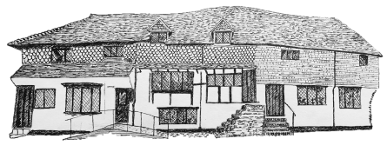
Midhurst Town Council
The Old Library, Knockhundred Row, Midhurst, GU29 9DQ
01730 816953 clerk@midhurst-tc.gov.uk www.midhurst-tc.gov.uk

The Burial Authority for the Parish of Midhurst
Request to Transfer Exclusive Right of Burial in Midhurst Cemetery
Carron Lane, Midhurst, GU29 9LF

Name of Applicant/Transferee ______________________________________________(please print)
Relationship to original owner (including next of kin status) _____________________________
__________________________________________________________________________________
Address including postcode ___________________________________________________________
__________________________________________________________________________________
Contact telephone number/s __________________________________________________________
Contact email address________________________________________________________________
Current owner/Transferer ____________________________________________________________
Plot number (if known) _______________________________________________________________
Reason for transfer (e.g. Owner deceased)
__________________________________________________________________________________
Signature of original owner (if possible)__________________________________________________

Signature of person to whom right is to be transferred ______________________________________

For office use
Plot number __________ Grave register entry ____________ Register of Transfer _______________

Interred ____________________________ Burial Register Entry ___________________________
Date of original purchase __________________________

