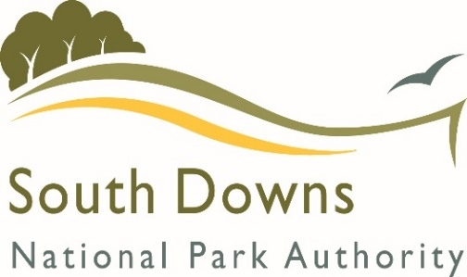**Community Infrastructure Levy**

**Parish / Town Council Payments (Regulation 62A)**

**Annual Monitoring Return**

**What should this form be used for?**

Your Parish / Town Council has received a payment from the Community Infrastructure Levy (CIL). The Community Infrastructure Levy Regulations 2010 (as amended) require us to monitor if that money has been spent and if so, what has been provided. Therefore, please complete the tables below.

|  |  |
| --- | --- |
| 🛈 | Please note that all payments made by 30th April each year account for a payment within the previous financial year. E.g., A payment received in April 2021 will be reported in the financial year of 2020-2021.  The money you have been paid must be used within 5 years of receipt or may have to be returned. |
|

If you have any queries, please do not hesitate to contact us on 01730 819360 or e-mail [cil@southdowns.gov.uk](mailto:cil@southdowns.gov.uk)

**YOUR DETAILS**

|  |  |
| --- | --- |
| Parish / Town Council | Midhurst Town Council |
| Name (& position if applicable) | Sharon Hurr |

**Reporting Year: 2020-2021**

|  |  |
| --- | --- |
| **CIL Receipts Received Summary** | |
| 1. Total CIL receipts received (from all reporting years) | **£98,025.48** |
| 1. CIL Receipts received in October 2020 | **£0.00** |
| 1. CIL Receipts received in April 2021 | **£0.00** |
| 1. CIL Receipts from previous reporting years (i – ii – iii) | **£98,025.48** |

|  |  |
| --- | --- |
| **CIL Receipts Retained** | |
| What is the total amount of CIL received in the reporting year (ii + iii) and unspent at the end of the financial year (31st March 2022)? | £0.00 |
| What is the total amount of CIL received in previous reporting years (iv) and unspent at the end of the financial year (31st March 2022)? | £98,025.48 |
| What is the total CIL receipts unspent? | £5,775.00 |

|  |  |  |  |
| --- | --- | --- | --- |
| **Expenditure** | | | |
| Please provide us with a summary of what you have spent from the CIL grant during this past financial year (1st April 2019 – 31st March 2021 (two years) | | | |
| **Infrastructure item**  *E.g., Playground equipment* | **Total CIL spent on project** | **Date of expenditure** | **Notes or comments** |
| Northern Gateway Project licensing | £80.00 | 8/9/2021 | Excluding VAT |
| Northern Gateway Project soil testing, plant design | £1,525.00 | 13/9/2021 | Excluding VAT |
| Northern Gateway Project planning application | £485.33 | 17/11/2021 | Excluding VAT |
| Northern Gateway Project block plan for planning application | £11.00 | 2/12/2021 | Excluding VAT |
| Northern Gateway Project sign design | £1,550.00 | 29/12/2021 | Excluding VAT |
| **Total expenditure for reported year:** | **£3,651.33** | | |

*If your project is under way or complete, please provide us with photographs, publicity, notes or other interesting materials where available so that we can use these as case studies for other groups.*

|  |  |
| --- | --- |
| **Details of any receipts that the SDNPA have asked you to return (in accordance with regulation 59E):** | |
| Total value of CIL receipts subject to the aforementioned notices during the reported year | £0 |
| The total value of CIL receipts subject to the aforementioned notices in any year that has not been paid. | £0 |

|  |  |
| --- | --- |
| **Publishing Your Report** | |
| Please provide the parish council website link where you intend to publicise this report:  *All Parish and Town Councils are required to display this form, or an equivalent, on their own websites no later than the 31st December after each financial year.*  If you are unable to publish this information on your own website, the SDNPA can act as a substitute, but you must inform us that this is the case. | **Midhurst Town Council Website** |

Signed: 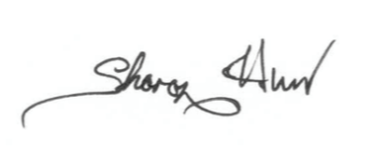

Date: 19th December 2022