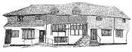

Midhurst Town Council

**Meeting of Midhurst Town Council took place on**

**Monday 22nd September 2025 at 7:30pm in**

**Midhurst Town Council Offices, Old Library, Knockhundred Row, Midhurst, GU29 9DQ**

**MINUTES**

**Present**: Cllr D Coote, Cllr A Lambert, Cllr D Martin, Cllr G McAra, Cllr D Merritt (Town and Chichester District), Cllr P Piper, Cllr R Watts (Chairman) and Cllr J Travers.

**In attendance**: S Hurr (Town Clerk)

**C/041/25 Chairman’s Announcements:** The Chairman welcomed Councillors to the meeting.

**C/042/25 Apologies for Absence:** Received from Cllr C Gilson, Cllr D Fraser and County Councillor Y Gravely.

**C/043/25** **Declarations of Interest:** None

***Meeting halted for Public Participation Session***

**C/044/25 Public Participation Session:** No public were present, and no questions had been received.

***Meeting reconvened.***

**C/045/25 Report from County, and District Councillors:** There was no report on this occasion from County Councillor Gravely.A report was circulated by District Councillor Merritt prior to the meeting (see appendix one). Cllr Merritt drew attention to the issue of air quality in Rumbolds Hill which had significantly improved potentially due to the introduction of low emissions buses. Cllr Travers commented that lorries travelling to Pendean Quarry would halt at the end of the month, and Cllr Piper further commented that petrol/diesel vehicles would always produce pollution particularly in relation to catalytic converters when vehicles were travelling at low speed, and increased particles from tyres due to the weight of batteries in electric vehicles.

**C/046/25 - Minutes of the Previous Meetings (and actions):** The minutes of the meeting held on 28th July 2025 were proposed by Cllr Piper, as a correct record, seconded by Cllr McAra, agreed by all present and adopted. The minutes of the Extraordinary General Meeting held on 26th August 2025 were proposed as an accurate record by Cllr Martin, seconded by Cllr Merritt, agreed by all present, adopted and signed.

**C/047/25 - Matters Arising from those Minutes:** None

**C/048/25 Reports from Outside Meetings:** Cllr Martin reported that she had been pleased with potentially gaining thirteen new volunteers for the Midhurst Community Growing Garden project at the Summer Street Party and hoped she would be able to have a stall at the Christmas Street Party to further raise interest.

**C/049/25 Conclusion of Notice of Annual Governance and Accountability Return – 2024-25:** The Clerk circulated a short report listing the comments received from the external auditor (see appendix two). Cllr McAra sought clarification upon whether the Council could select its own external auditor and the Clerk responded that this was possible but the requirements of doing so were onerous and the Clerk was not aware of any Councils which had chosen not to use the Government appointed external auditor. The Chairman iterated the comment received regarding the Council’s low general reserves and confirmed that this situation was constantly under review.

**C/050/25 Carron Lane Play Park Update:** Cllr McAra, reported that a grant had been secured from South Downs National Park for £20,000. Cllr McAra further reported that to date seven playground providers had been approached and appointments had been made with three of the companies. Cllr McAra commented that the focus would be on installing equipment/facilities requested in the survey work with a design in principle prepared for Councillors consideration in November prior to an application to Chichester District Council for funding.

**C/051/25 Cemetery Lodge Update:** The Chairman reported that the property required a new kitchen and bathroom and further general decoration, adding that the adjoined garage would be returned to use for a vehicle.

**C/052/25 Matters of Report:** Cllr Merritt confirmed that West Sussex County Council would remove flags attached to lampposts.

Councillors were reminded that Andrew Griffiths MP, would be holding a ‘Meet Your MP’ at 6.00pm on 24th September 2025.

**C/053/25 Date of Next Meeting:** 7.30pm, 27th October 2025

The meeting ended at 8.00 pm.

Signed………………………………………………………… Dated……………………………………….

Chairman

Appendix One

**District Councillor Report – Midhurst Ward**

**Midhurst Town Council**

**Monday 22nd September 2025**

It has been a very busy few months as the District Councillor for the Midhurst Ward, with a wide range of casework, community visits, and local events. Over the summer, I was especially pleased to spend time across the ward and wider district, meeting community groups and charities to see first-hand the incredible work they do.

**The Fire Damaged Buildings**

A meeting was held on 26th August 2025 with all the owners of the fire damaged buildings, and representatives of the South Downs National Park Authority, Historic England, Chichester District Council, Midhurst Town Council, Midhurst District Councillor and County Councillor were also present.

The meeting’s purpose was to review any progress each of the owners have been able to make and to understand what might be needed to break any deadlock, and how this might be facilitated.

The situation is extremely complex with several businesses and insurance companies involved, and the personal toll on the owners, together with the impact on other businesses in the town, were made very clear throughout the meeting.

The façade of the buildings was discussed at great length including the steps needed to decide whether they should be retained or not, and progress was made in understanding the next steps for the owners, with support, where possible, from the authorities. These steps will be pursued, and further meetings will be arranged as required.

It is impossible, due to the complexities, to be specific about the details of the situation, the potential outcome, or indeed any timescales at this stage. There are still so many issues to be resolved from an insurance, and a logistical perspective where each of the owners are dependent upon each other.

However, after two and a half years, this was an important and positive step and everyone was in agreement that continuing the dialogue going forward, is hugely important to the businesses and residents of Midhurst, and for the future of the town.

Also, since the meeting, Yvonne has sent requests for quotes to three companies recommended by SDNPA. Yvonne has also contacted WS Fire service to inform them about the anxieties of residents in Angel Yard. They assured Yvonne they were doing audits of the flats this week and were sending someone out to review the available Hydrant and access issues. They have yet not got back to Yvonne.

A big thank you to Mary-Anne Kauntze and Midhurst Town Council for leading the hoardings painting project, which has helped brighten the area in the meantime.

**Lychgate (Market Square)**

The District Council is responsible for the maintenance of closed churchyards i.e. those that have no more room for burials and have been closed through an Order in Council (the Monarch). For many years the council has maintained the St Mary Magdalene & St Denys churchyard. The responsibility for maintenance includes boundary walls, fences and gates. When the Lychgate was found to be subsiding it was assumed the responsibility for maintenance would rest with the District Council. However, some doubt was cast over this when new information about the structure’s origins came to light. It transpires the Lychgate was constructed after the closure of the churchyard, unlawfully on unregistered land, all with best intentions of course. This required further investigation to confirm responsibility for the structure; the District Council, the Parochial Church Council, the Town Trust or all three.

The matter proved so complicated; it was agreed that independent legal counsel would be sought. Counsel advised that it was something of a unique case but on the balance of probability the structure could be considered part of the churchyard curtilage and therefore owned by the Church. This opinion has been shared with the Church and we are awaiting a response. The position the Diocese has to be happy with is accepting ownership, taking into consideration the potentially unlawful construction on unregistered land. If it is, then ownership will rest with the Church but the District Council responsibility to maintain it will apply and the next steps towards its repair can begin.

It is worth noting that repair will not be straightforward. It may be possible to raise the structure and repair, or it may be necessary to carefully dismantle and rebuild. Advice is currently being taken on this. The reason for subsidence will not be fully understood until the timber legs have been excavated. If it is due to wood rot this could be straightforward to address, but if it is due to ground conditions it could become more complicated. I say this only to manage expectations. As time consuming as this issue has been there is still considerable work to be done, below:

1. Receive confirmation from the Diocese on ownership.
2. Agree the approach needed to investigate the reason for subsidence i.e. lift or dismantle.
3. Agree access arrangements with the Town Trust to enable investigation and repair. The Trust is entirely supportive in this regard so this shouldn’t be a problem.
4. Determine repair options and feasibility.
5. Obtain a faculty (permission) from the Diocese to complete repairs. This will include a specification, detailed drawings and approval of the contractor to be used.
6. Proceed with repair.

The above assumes the Diocese will confirm ownership. It may reasonably be concerned about the origins and status of the lychgate so need to give it careful consideration. There is

the possibility it feels unable to accept ownership in which case we are back to the drawing board. It will take some time to move through these stages, so I think it is important to stress the continued complexity and this won't be a quick fix. But many would argue that is right in the circumstances as any repair has to be done correctly.

**Rumbolds Hill, Midhurst - Air Quality Management Area Revocation.**

CDC declared an Air Quality Management Area (AQMA) in Rumbolds Hill, Midhurst in 2020 when the air quality monitoring confirmed that air quality there was non-compliant with the government’s annual mean standard for Nitrogen Dioxide (NO2). Air quality in the AQMA has now been compliant, by more than 10% of the air quality standard’s value (labelled as ‘objective on the graph below), for more than three years.

Under such circumstances DEFRA’s statutory guidance suggests that it is appropriate to formally revoke the AQMA. As such CDC have a paper going to this authority’s 22nd September Environment Panel and then to the council’s 7th October 2025 Cabinet proposing the revocation. The revocation order will then be made after the ten-day cooling-off period for Cabinet decision. That will be around 20th October. The AQMA will then cease to exist.

The good news is that the air quality in Rumbolds Hill has, as documented by the council’s ongoing air quality monitoring, improved significantly. This is likely due to the integration of zero-emission vehicles into the fleet and Euro-6 Standard engine vehicles. CDC will continue to monitor at Rumbold’s Hill and on North Street for the foreseeable future in order to continue to review air quality there and report it in this authority’s annual statutory Annual Status Report which is audited annually by DEFRA.

**CDC Wellbeing Team**

Following meetings with the CDC Wellbeing Team, we will be bringing a **“Live Well” Midhurst Event** to Midhurst. Building on the success of the Men’s Health Fairs held across the district, this event will focus on wellbeing for all genders, with additional activities aimed at supporting young people. The event will take place at The Grange Community and Leisure Centre, with further planning meetings scheduled and the date to be confirmed.

Further to the CDC Wellbeing Team, they are also hosting the below events across the district with all the necessary information:

**Weight Better Life**

** Last few spaces available**

Our 12-week programme called Weigh Better Life focuses on healthy eating, nutrition and exercise. These workshops cover a wide variety of topics from challenging the myths about diets, bloody sugar balance, snacks and treats, exercise and how stress and lack of sleep may affect appetite and food cravings.

Starting September 2025

* Wednesday 17 September 10am, The Grange, Midhurst

Eligibility:

* BMI between 25 and 40 (BMI calculator: [Calculate your body mass index (BMI) - NHS - NHS (www.nhs.uk)](https://url.uk.m.mimecastprotect.com/s/nb1DCAQgVHN37O9h9ioCGvV8B?domain=nhs.uk/))
* Attend all 12 weeks of the course
* Complete this form to register: [Chichester Wellbeing Weigh Better Life (microsoft.com)](https://forms.office.com/Pages/ResponsePage.aspx?id=Kb3odV0Lt0Cy7UN4DnFKhfd_jW2T7vNLrCMJKFvwETRUOE9XVzZFMFZIN0RSOVhBUTczTEEyN05IQi4u)

Once the form is completed one of our weight management co-ordinators will be in touch.

If you have any further questions, please call: 01243 521041

**Active for life – free 10-week beginners exercise class**

A free 10-week course aimed at adults currently doing less than 150 minutes a week of exercise who wish to increase their activity levels and confidence. The courses are starting the week commencing 6th October:

* Wednesday 8 October 1pm, Thrive, Selsey
* Thursday 9 October 10.30am, The Grange, Midhurst
* Friday 10 October 10.30am, The Westgate Leisure Centre, Chichester

Eligibility:

* Resident of Chichester or Surrounding Villages
* Currently do less than 150minutes exercise / activity a week - if you do more activity than this you will not get the most benefit and enjoyment from the course, and we will not be able to offer you a place.
* You must be able to get up and down off of the floor
* Must be 18 or older
* Can attend all 10 weeks

If you are interested in joining then here is the link to our [online registration form](https://forms.office.com/e/wxNT7NL5fw). If you have any questions, you can call the office on 01243 521041 or email [wellbeing@chichester.gov.uk](mailto:wellbeing@chichester.gov.uk).

**Damaged Wall (Chichester Road)**

I am continuing to work on this issue. Hyde maintain that the repair is not their responsibility and that it falls to West Sussex County Council (WSCC) to repair. The matter is currently under review by the WSCC legal team.

Yvonne is assisting me with this case. Progress has been slow, so I have written again to the WSCC legal team to request further information to help move matters forward.

**Visit to Midhurst Palliative Care**

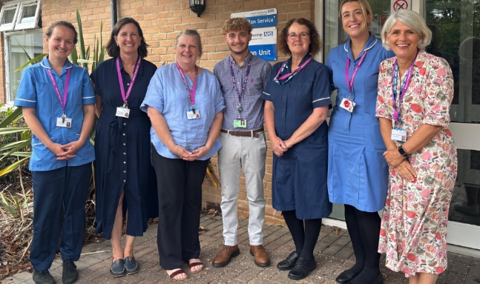During the summer, it was great to visit Midhurst Palliative Care located at The Pearson Unit, in Easebourne.

I met with Joanna Stuttaford – MacMillan Service Lead, and Emma Harrison – Fundraising Manager, who took me through the day-to-day operations of this incredible service and showed me around the wonderful premises. From the dedicated staff to the passionate volunteers, I was truly inspired by the huge community they support.

We spoke about how they support patients medically but also with their wellbeing, fundraising, volunteering opportunities, and how the Trustees, Joanna, and Emma all work hand-in-hand to make a difference. This service goes far beyond supporting patients with terminal cancer, they are there for people with a wide range of terminal medical needs.

I also had the chance to visit the beautiful memorial gardens with Emma. Despite having lived in Midhurst for many years, it was my first time there, and it was incredibly special.

If you would like to get involved, volunteer, or donate, please visit their website - [www.mpc-midhurstmacmillan.org](https://url.uk.m.mimecastprotect.com/s/TuQZC3jPAhpPLo7hgf3tQgymu?domain=mpc-midhurstmacmillan.org)

e.**

Independent high street businesses that trade during the evening and night-time in Chichester District could get a funding boost thanks to a new business grant being offered by Chichester District Council. The new Evening and Night-time Economy Business Grant will be available to independent businesses with a physical premises on high streets in Chichester, East Wittering, Midhurst, Petworth and Selsey.

The grant offers an exciting opportunity and is ideal for those businesses keen to develop a new offering for their customers in order to help increase footfall and client spend. It is also aimed at businesses who want to create a more exciting experience for customers or those who want to collaborate with other high street businesses to offer evening entertainment. As well as established businesses, the grant is also aimed at businesses that have plans to start trading during the evening and night-time to help support their new enterprise.

The grant is one of several key actions highlighted in the council’s recently launched Economic Development Strategy and is being offered in direct response to feedback from businesses in the district. The grant available will be up to 50% of eligible costs, to a maximum contribution of £3,000. The business must contribute the remaining 50%. Applications are now open at [**www.chichester.gov.uk/entebusinessgrant**](http://www.chichester.gov.uk/entebusinessgrant) where further information and detailed guidance notes are available. The deadline for applications is midnight on 5th of October.

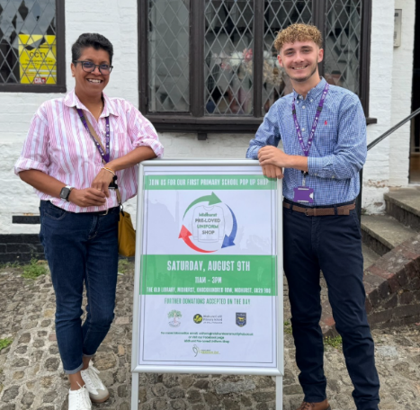**Opening the Pre-Loved Pop-Up Uniform Shop - Midhurst Community Hub**

On the 9th of August, I was delighted to officially launch the Pre-Loved Pop-Up Uniform Shop at The Old Library. This community-led initiative, spearheaded by Laura and the Midhurst Community Hub, provides affordable school uniforms to families in need. The project will continue year-round, and it was wonderful to see so much community support.

**Land at The Grange**

No formal interest yet, though affordable housing companies have made enquiries and been referred to CDC Estates Team. Along with Cllr Hannah Burton, my priority is to get affordable housing on this land as soon as possible.

**Midhurst Police Station**

I am continuing to work with Cllr Tracie Bangert, Cabinet Member for Communities and Wellbeing, to confirm when Midhurst Police Station will be staffed and able to reopen. I have also met with Pam Bushby, Divisional Manager for Communities and Wellbeing. The delay is due to waiting on office administration staff, and we are still awaiting confirmation from the admin team. Residents’ concerns have been raised and pressure applied to help move this forward.

I have also explored the possibility of extending the reach of community wardens across the district to Midhurst. However, this would require funding from parish councils. While the City Council funds this in Chichester, the cost is substantial, and discussions with CDC staff indicate that wardens would not be as effective in the Midhurst Ward compared to Chichester.

I will also be arranging a walkabout with PCSO Nathan Ford (date to be confirmed) around Midhurst. If you would like to join, please do let me know.

**Hyde Service Charges and Housing Regeneration Strategy**

Many residents have raised concerns with me regarding Hyde service charges, particularly the difference between these charges and council tax. Residents feel that the level of service provided by Hyde does not reflect the costs, as they often carry out much of the work themselves. I am meeting with residents to discuss these concerns and referring complex cases to our Housing, Revenues, and Benefits team, who are working with Hyde to resolve them.

I also had a positive meeting with Hyde regarding social housing opportunities in the Midhurst Ward and their regeneration strategy. Many properties in the ward, 85 in total were built between 1971 and 1984 and, due to their age, require ongoing maintenance. The regeneration strategy aims to replace some of these older homes with modern, rebuilt properties, ensuring they meet current standards. This is a long-term process, involving planning approvals, drawing up plans, and securing suitable temporary accommodation for affected residents. Hyde expects this work to begin around 2030.

In addition, Hyde plans to deliver 4,000 new social homes across the Midhurst Ward, separate from the regeneration programme, to support residents in need of social and affordable housing.

**Supporting Residents During the Winter Months**

Following a Social Prescriber drop-in event at Riverbank Medical Centre on Monday 1st of September, loneliness and heating costs were highlighted as a concern from residents across the Midhurst Ward. Plans are underway with CDC, social prescribers, and local businesses to relaunch warm spaces this winter and social support

**Tufts Field Parking Concerns**

I am working with Hyde Housing and West Sussex County Council (WSCC) to address ongoing parking concerns raised by residents of Tufts Field, Midhurst. The primary issue is the lack of available parking spaces, with some households owning more than four vehicles.

At present, an unofficial area is being used for parking, a former pavement strip (lagoon strip) that has since become grassed over. This space could potentially be converted into designated parking bays. In addition, Hyde garages in the area present another opportunity. Some garages are underused or remain rented but not actively utilised. Recent surveys indicate that removing certain garages could free up land for additional parking spaces, which would help alleviate current pressures.

Parking challenges are particularly challenging across Tufts Field and Meadway, and this remains an ongoing campaign in collaboration with residents. I am continuing to work closely with Hyde and with Cllr Yvonne Gravely on this matter. Once final information is confirmed by Hyde, I will be sending a formal letter to WSCC to support residents in finding a long-term solution.

**Visit to Chichester District Foodbank**

On Monday 11th August, I visited Chichester District Foodbank to gain a better understanding of the vital service they provide to residents across the district, with particular relevance to those living in the Midhurst Ward.

During my visit to their Chichester facilities, I met with Sarah, the CEO, and her dedicated team of volunteers, whose commitment to supporting local families is evident in their work. Sarah highlighted the concerning reality faced by many households, including some in Midhurst, where individuals, particularly women often feel too fearful or ashamed to seek help or access the food bank’s services.

**Coach Bays and Storage – Midhurst Carparks**

On Thursday 18th September, I met with Cllr John Cross, Cabinet Member for Growth and Place, to discuss storage at the Bus Stand (North Street Car Park) and the potential for coach bay parking at the Grange Road Car Park.

At the Bus Stand storage area, concerns were raised regarding the current entry point, which is not considered safe for moving equipment due to the presence of plastic pipes leading to the toilets. Cllr Cross suggested creating an alternative access point at the rear of the building near Disking, with the existing door retained solely for boiler access for the barbers. These proposals will now be reviewed by Officers, and I will be updated on the outcome in due course.

At the Grange Road Car Park, we looked at options for introducing coach bay parking. It was noted that four WSCC parking bays are currently unused, as staff use the MiPermit app for free parking. These bays could be repurposed as coach bays, with additional possibilities identified along the lower section of the car park. The existing drop-off/pick-up bay outside the Grange was also highlighted as a potential coach drop-off/pick-up point. Should coach bays be introduced, turntables would be required, and this matter has also been referred to Officers for consideration, with further updates to follow.

I raised ongoing concerns regarding parking along West Street, particularly in relation to the TRO application for double yellow lines. I also asked whether CDC’s parking team would enforce restrictions on vehicles parked during the evening. Cllr Cross confirmed that if parked cars are reported, the enforcement team would respond proactively, and patrol affected areas during the evenings.

**Rother Valley Together – Community Walk**

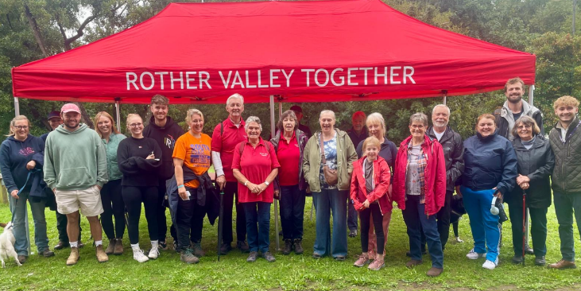I was delighted to be asked to attend the Rother Valley Together Community Walk on Sunday 14th of September. It was wonderful to see so many members of the public, staff, and dedicated volunteers coming together for such a great cause.

A total of 75 walkers took part, raising £1,359 to support Rother Valley Together, helping fund activities, lunches, and days out for their members.

**District and County Councillors Surgery**

Our joint District and County Councillors’ surgery was held on Saturday 23rd August at The Grange Community and Leisure Centre. The surgery was well attended, with residents raising a wide range of issues, from parking concerns to business support.

Our next surgery will take place on Saturday 27th of September from 1pm–3pm at The Grange Community and Leisure Centre. Residents, businesses and Parish Councillors are encouraged to book an appointment if they wish to discuss any questions or concerns.

**Planning for Devolution and Local Government Reform**

On Tuesday, Full Council will meet to vote on the Local Government Reform (LGR) plan. Residents across the district were consulted to share their views and concerns regarding the proposed changes.

Significant work has been carried out by Diane Shepperd, CEO at CDC, and Adrian Moss, Leader of the Council, including meetings with other council and borough leaders to explore and agree on potential unitary options.

Consultation feedback showed strongest support for a two-unitary model, referred to as B2:

* **South/West:** Chichester, Arun, Worthing & Adur
* **North East:** Mid Sussex, Horsham & Crawley

Council and borough leaders are backing the B2 option. A press release and update will follow the vote to inform parishes and residents across the district.

**August Report – (01/08 – 31/08)**

During August, work in the Midhurst Ward included handling casework, visiting local charities and community groups, and attending resident surgeries. My August report can be found here -

If you have any questions about this report, need support with a project, or wish to raise any concerns, please don’t hesitate to get in touch.

|  |  |
| --- | --- |
|  | **Dominic Merritt** Chichester District Councillor Midhurst Chichester District Council |

Email: [dmerritt@chichester.gov.uk](mailto:dmerritt@chichester.gov.uk)

Phone: 07999 489718

Appendix Two

**Moore – External Auditor Comments**

* Section 137 – confirmed that the Council do not use this as the Council had insufficient Councillors at election, but this has been misread as we use Section 137
* Notice of Conclusion – this was published on the website last upon the conclusion of audit in August 2024 but was amended (2023 quoted rather that 2024) in November 2024 and republished, therefore has been taken as a late publication
* General Reserves – comment received that these are lower than good practice denotes and therefore should be kept under review

*Sharon Hurr*

*Town Clerk*

*15th September 2025*